Supporting information for
Nitrate removal from water using electrostatic regeneration of functionalized adsorbent
James W. Palko^{a,b,1}, Diego I. Oyarzun^{a,1}, Byunghang Haª, Michael Stadermann^{c}, Juan G. Santiago^{a,*}
ª Department of Mechanical Engineering, Stanford University, Stanford, CA 94305, USA
^{b} Department of Mechanical Engineering, University of California, Merced, CA 95343, USA
^{c} Lawrence Livermore National Laboratory, Livermore, CA 94550, USA
¹contributed equally
*corresponding author
E-mail: juan.santiago@stanford.edu
Phone: (650) 723-5689

Abstract
The supporting information presented here provides descriptions of UV spectrophotometric nitrate measurements, nitrate removal cycles at short circuit, inactive times between runs for the nitrate removal cell, and competitive adsorption of NO₃⁻ and Cl⁻.
List of Figures and Tables
Fig. S 1 | Calibration curves for UV absorbance of NaNO₃ . . . . . . | S-1
Fig. S 2 | UV-vis spectrophotometer absorbance of Sodium Bromide. . . . . . . . . . . . | S-2
Fig. S 3 | Cyclic adsorption of nitrate with active and counter electrodes shorted following electrical regeneration . . . . . . . . . . . | S-3
Table S 1 | Inactive delay time after each adsorption cycle. . . . | S-4
Fig. S 4 | Affinity of NO₃⁻ over Cl⁻ | S-4

- UV spectrophotometric measurements of nitrate concentration
We measured NO₃⁻ concentrations using a UV/Vis/NIR spectrophotometer (Agilent Cary 6000i) with a short path length (0.2 mm) quartz cuvette. To this end, we generated custom calibration curves for NO₃⁻ adsorption at wavelengths of 205 and 225 nm. Figure S1 shows the calibration curves relating solution concentration and absorbance.
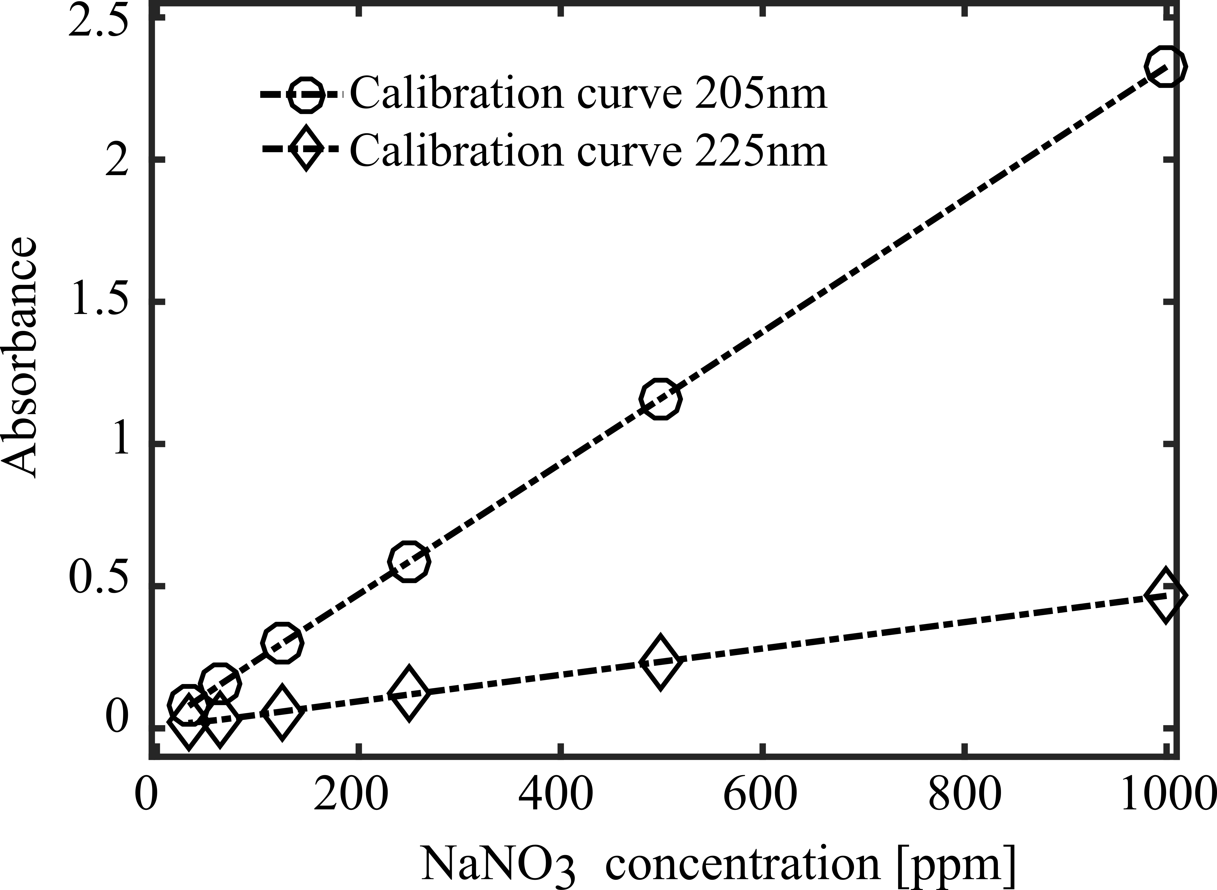
Figure S 1: Calibration curves for UV absorbance at 205 and 225 nm vs. NaNO₃ concentration for aqueous solutions using a 0.2 mm path length quartz cuvette. Shown are linear regression fits of the form y =x 2.33E- 3 (R = 1.00) for 205nm and y = x 4.674E-4 (R = 0.999) for 225nm.
We used a wavelength of 205 nm for determination of nitrate concentration when other anions were not present in solution (i.e. for cell cycles applying electrical regeneration after the initial ion exchange had completed). NO₃⁻ shows relatively strong absorption at this wavelength.
During the initial ion exchange of the first adsorption cycle following electrode surfactant treatment we detected the presence of Br⁻ ions in solution. For such solutions, we used a wavelength of 225 nm for nitrate concentration quantification. Bromide absorbs strongly at shorter wavelengths, but this absorption decays as wavelength increases to ~220 nm.
Figure S2a shows the absorption spectra for several concentrations of NaBr. At a wavelength of 225 nm the absorption of Br⁻ is negligible compared to NO₃⁻.

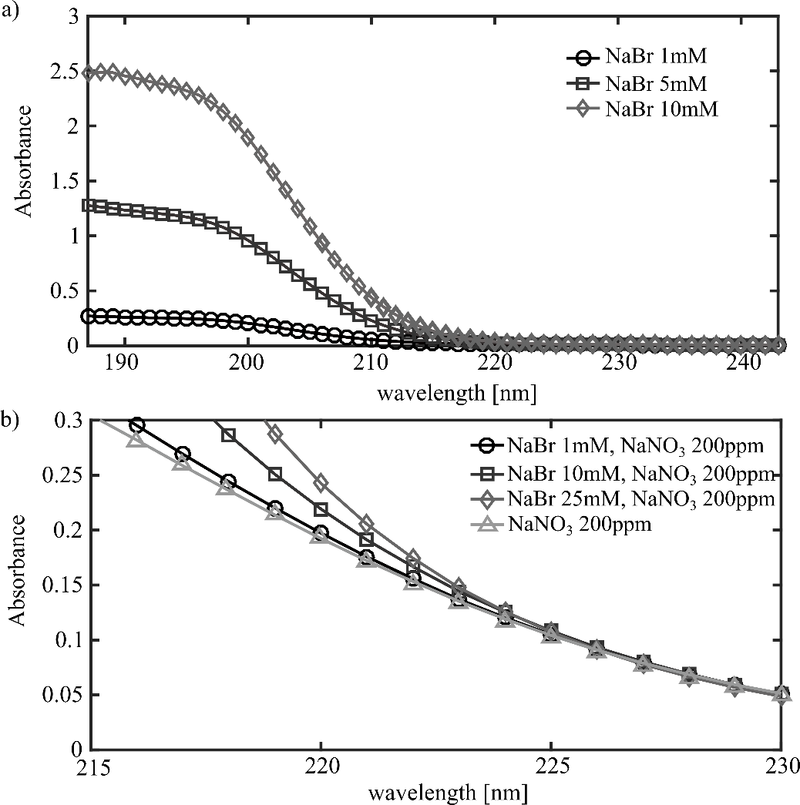
Figure S2b shows the absorption of 200 ppm NaNO₃ with varying concentrations of NaBr.
Figure S 2: UV Spectrophotometric measurements of anionic concentrations using a quartz cuvette with a 0.2 mm path length. a) Sodium Bromide absorbance vs. wavelength at 1, 5 and 10 mM concentrations. b) Absorbance vs. wavelength of NaNO₃ at 200 ppm without additional solutes and in solution with Sodium Bromide (1, 10, and 25 mM). Bromide ions show negligible absorbance at wavelengths greater than 225 nm.
- Nitrate adsorption under short circuit conditions
In addition to the open circuit adsorption cycles following electrical regeneration, two cycles (6 and 7) were conducted using a short circuit between the active and counter electrodes. Effluent concentration, cell voltage, and current are shown versus time in Figure S3. In these cycles, we used the same treated activated carbon electrode used for cycles shown in the main text Figure 3. Flow rate was fixed to Q = 0.43mL/min. Effluent concentration in these cycles shows similar behavior to that seen in open circuit cycles, indicating dominance of Faradaic reactions on the active electrode during adsorption.

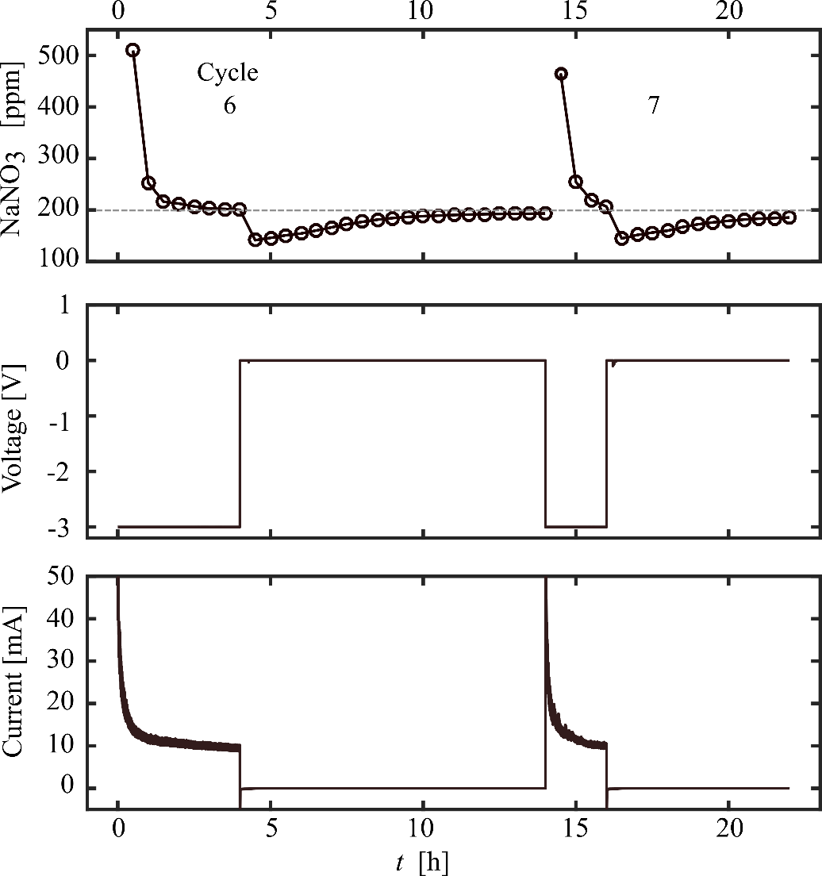

Figure S 3: Cyclic adsorption of nitrate with active and counter electrodes shorted following electrical regeneration. Time series showing a) Effluent NaNO₃ concentration, b) voltage, and c) current versus time for input concentration of 200 ppm NaNO₃ and fixed flow rate of Q = 0.43mL/min. The time axis has been abridged to include only active cell times.
- Cell inactive times
Cumulative times reported in the main text for multiple cycles refer to the times in which the cell was actively adsorbing or regenerating. Inactive times between runs are reported in Table S1. Zero delay between cycles refers to consecutive cycles. Inactive times were used to collect samples and inspect the cell

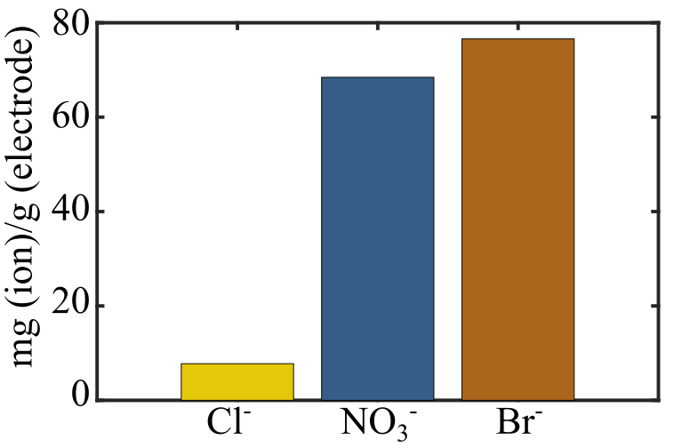
Figure S 4. Ion adsorption on CTAB-treated electrode material from starting solution of 2mM NaCl and 2mM NaNO₃. Results show chloride and nitrate adsorption capacity, and bromide desorption in units of mg of anion per mass of CTAB-treated electrode material.

Cycle | Delay after cycle, h
1 | 3
2 | 10
3 | 1
4 | 0
5 | 3
6 | 0
7 | 3
8 | 0
9 | 10
10 | 6
11 | 0
12 | -
Table S 1 Inactive delay time after each adsorption cycle.

- Nitrate affinity of CTAB-treated carbon electrode
In this section, we describe an experiment demonstrating relative ionic affinity of a CTAB-treated activated carbon electrode. First, we submerged a CTAB-treated electrode with dry mass of 0.14 g in 50mL of 2mM NaCl and 2 mM NaNO₃ solution. Following overnight equilibration, we measured the resulting solution composition by ion chromatography (DIONEX DX 500, DIONEX, CA, USA).
Figure S4 shows chloride and nitrate adsorption capacity, and bromide desorption for the CTAB-treated electrode. Results show about 8 and 68 mg g⁻¹ adsorption capacity for chloride and nitrate ions, respectively and 77 mg g⁻¹ desorption of bromide ions. Figure S4 thus indicates the higher nitrate affinity of the CTAB-treated electrode material compared to chloride.

